SE307 Concepts of Programming Languages

Booking a Room System

Final Report

Berk Arkan

24/06/2021

**Project Explanation:**

This project aims to simulate a hotel booking system. It has been written in c# programming language in Microsoft Visual Studio.

There are two types of users as set by the requirements, admins and residents. User type logins are handled automatically, the users and admins only need to enter their credentials and they will be given proper access regarding their account type. The users can log in and out at any time they desire, the program allows changing users. If the password or username is not found or does not match, an error will be given and credential will be asked again.

The admins can add, set/edit their information, remove, and display certain information. They can add new hotels, remove hotels, display all hotels information, display residents residing in a hotel or just print out all the resident information. They can also print out an info.txt file which will print out all the hotels reservation info as a log.

The residents can book rooms not just with their name but can also book multiple rooms and other people. They can view hotel information and all the vacant rooms with 2 different menus. If a resident tries to book an already booked room an error will be given and they will be asked to try again. They could also see the pricing of the hotel rooms.

Example of a user login: Example of an admin login:

.

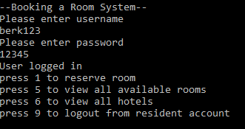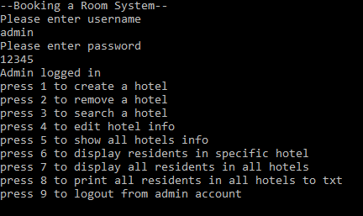

Example of hotel creation: Example of hotel display

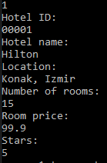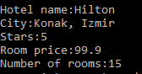

Booking process:

viewing available rooms:

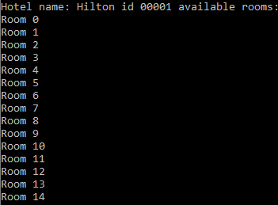

Booking room number 5:

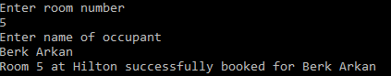

Room 5 no longer visible:

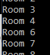

Logging out as resident, and back in as admin, then viewing all bookings:

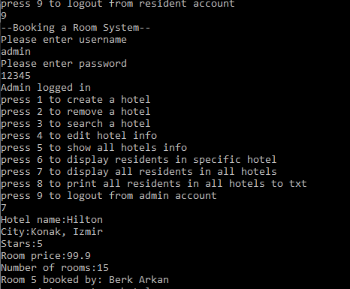

As expected, The booking is shown.

Object oriented approach:

The admin and resident classes are derived from the user class with an is a relationship, theese classes extend the user base class which hold the username ans password.

Rooms are objects contained in the hotel object. The users are also “objects” with admin and resident being different as they require different fields inside them.

By using objects, we can create multiple instances of “room” inside hotel using lists with ease, after doing this we could also make several instances of hotel and they will in return contain multiple rooms inside them. This makes the program expandable. The hotel and rooms are in a composition relationship.

The program class contains hotels and users.

